**Objective**: Learning about how to grant and revoke permission to any users.

**Security Management**: Oracle provides extensive security features in order to safeguard information stored in its tables from unauthorized viewing and damage. Depending on a user’s status and responsibility, appropriate rights on Oracle’s resources can be assigned to the user by the DBA.

Objects that are created by a user are owned and controlled by that user. If a user wishes to access any of the objects belonging to another user the owner of the object will have to give permission for such access. It is called Granting Privileges.

Privileges once given can be taken back by the other owner of the object. This is called Revoking Privileges.

**Object Privileges:** Object Privileges is each object privilege that is authorizes the grantee to perform some operation on the object. A user can grant all the privileges or grant only a specific object privileges.

Here is the list of object privileges:

1. **ALL:** Allows the grantee to do ALL the action.
2. **ALTER:** Allows the grantee to change the table definition.
3. **DELETE:** Allows the grantee to Remove the records from the table.
4. **INDEX:** Allows the grantee to create an index on the table.
5. **INSERT:** Allows the grantee to add records to the table.
6. **SELECT:** Allows the grantee to query the table.
7. **UPDATE:** Allows the grantee to modify the records

**[WITH GRANT OPTION]** allows the grantee to in turn grant object privileges to other users.

**Granting Privileges using the GRANT statement:**

**SQL syntax:**

GRANT <Object Privileges> ON <ObjectName> TO <UserName> [WITH GRANT OPTION];

Ex: GRANT ALL ON stuent_table TO mamun

**Some Example On Granting Privileges:**

I have create an user named ‘mamun’ and give SELECT privilege to it from the account ‘sys’. ‘sys’ have table named student.

1. **Before granting SELECT Privileges:**

**SQL:** SELECT *FROM sys.student

**Output:**



**After granting SELECT privileges:**

**SQL:** GRANT SELECT ON student TO mamun;

SELECT *FROM sys.student;

**Output:**

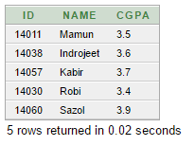

1. **Before granting INSERT Privileges:**

**SQL:** INSERT INTO sys.student VALUES(14014,'Alamin',3.55)

**Output:**



**After granting INSERT privileges:**

**SQL:** GRANT INSERT ON student TO mamun;

INSERT INTO sys.student VALUES(14014,'Alamin',3.55)

SELECT *FROM sys.student;

**Output:**

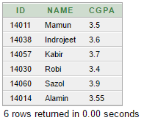

1. **Before granting DELETE Privileges:**

**SQL:** DELETE FROM sys.student WHERE id=14014 OR id=14060

**Output:**



**After granting DELETE privileges:**

**SQL:** GRANT DELETE ON student TO mamun;

DELETE FROM sys.student WHERE id=14014 OR id=14060

SELECT *FROM sys.student;

**Output:**



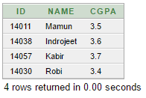

1. **Before granting INDEX Privileges:**

**SQL:** CREATE INDEX std_index ON sys.student(id);

**Output:**



**After granting INDEX privileges:**

**SQL:** GRANT INDEX ON student TO mamun;

CREATE INDEX std_index ON sys.student(id);

SELECT rowid, id, name FROM sys.student;

**Output:**



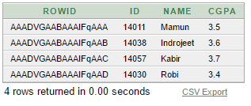

1. **Before granting ALTER Privileges:**

**SQL:** ALTER TABLE student ADD (address VARCHAR2(20));

**Output:**



**After granting ALTER privileges:**

**SQL:** GRANT ALTER ON student TO mamun;

ALTER TABLE student ADD (address VARCHAR2(20));

DESCRIBE sys.student;

**Output:**



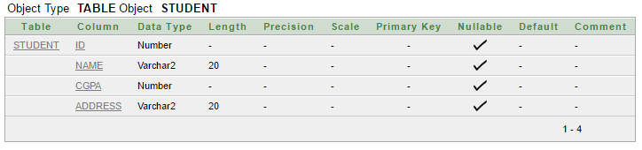

**Revoking privileges given:** REVOKE statement is used to deny the grant given on an object.

**Syntax:** REVOKE <Object Privileges> ON <ObjectName> FROM <UserName>

**Ex:** REVOKE DELETE ON student_table FROM mamun;